1. What is the truth table of the following symbol?

|  |  |  |  |  |  |  |  |  |  |  |  |  |  |  |  |  |
| --- | --- | --- | --- | --- | --- | --- | --- | --- | --- | --- | --- | --- | --- | --- | --- | --- |
|  | |  |  |  | | --- | --- | --- | | A | B | X | | 0 | 0 |  | | 0 | 1 |  | | 1 | 0 |  | | 1 | 1 |  | |
|  |  |

1. How is the following circuit called and what does it do? Explain its functioning coloring the lines having value 1. The values for the lines are A=1, B=0, C=1, D1=0, D2=1, D3=1, D4=0, D5=0, D6=1, D7=0. Determine the value of F.  
     
   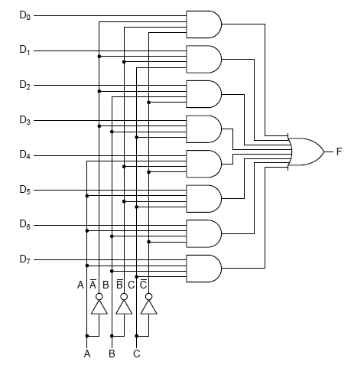
2. What is the goal of pipelining? How is this goal achieved?
3. What is a memory hierarchy? What does it describe?
4. Draw a circuit for the following truth table:

|  |  |  |  |
| --- | --- | --- | --- |
| A | B | C | M |
| 0 | 0 | 0 | 0 |
| 0 | 0 | 1 | 0 |
| 0 | 1 | 0 | 0 |
| 0 | 1 | 1 | 1 |
| 1 | 0 | 0 | 0 |
| 1 | 0 | 1 | 1 |
| 1 | 1 | 0 | 1 |
| 1 | 1 | 1 | 1 |

1. Explain the functioning for the following 1-bit ALU coloring the lines having value 1. The values of the lines are A=1, B=1, Carry in=0. Determine the value of F0, F1, INVA, ENA, ENB, Carry out, and Output **if you want to perform the operation A OR B.**  
     
   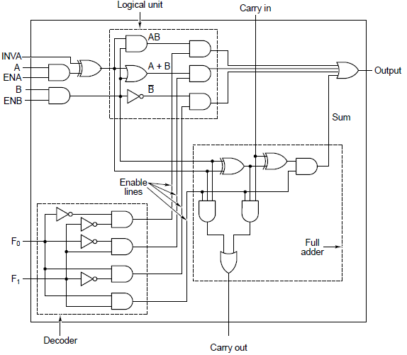
2. How does a latch work?
3. Convert 1234 into binary, convert DECAF into decimal.
4. Simplify the expression $\overline{A}\overline{B}\overline{C}\overline{D}+\overline{A}\overline{B}CD+\overline{A}B\overline{C}\overline{D}+\overline{A}BCD+AB\overline{C}\overline{D}+ABCD+A\overline{B}\overline{C}\overline{D}+A\overline{B}CD$ using a Karnaugh map.
5. Simplify the expression $\overline{A}BC+\overline{A}B\overline{C}+A\overline{B}\overline{C}+A\overline{B}C+ABC+AB\overline{C}$ using a Karnaugh map.